Configuring URL rules

viewPrefix

A string to be prefixed to the user-specified view name to form a complete view name. For example, if a user requests tutorial/chapi, the corresponding view name will be pages/tutorial/chapi, assuming that the prefix is pages. The actual view file is determined by yii\base\View::findViewFile().

The ViewAction action provides you a way to minify your controller, but the URLs look like http: //yii- book. app/index. php?r=test/page&page=about. To make URLs short and more readable, add a URL rule to urlManager component:

'<view:about>' => 'test/page'

If the urlManager component configures properly you will get the following:

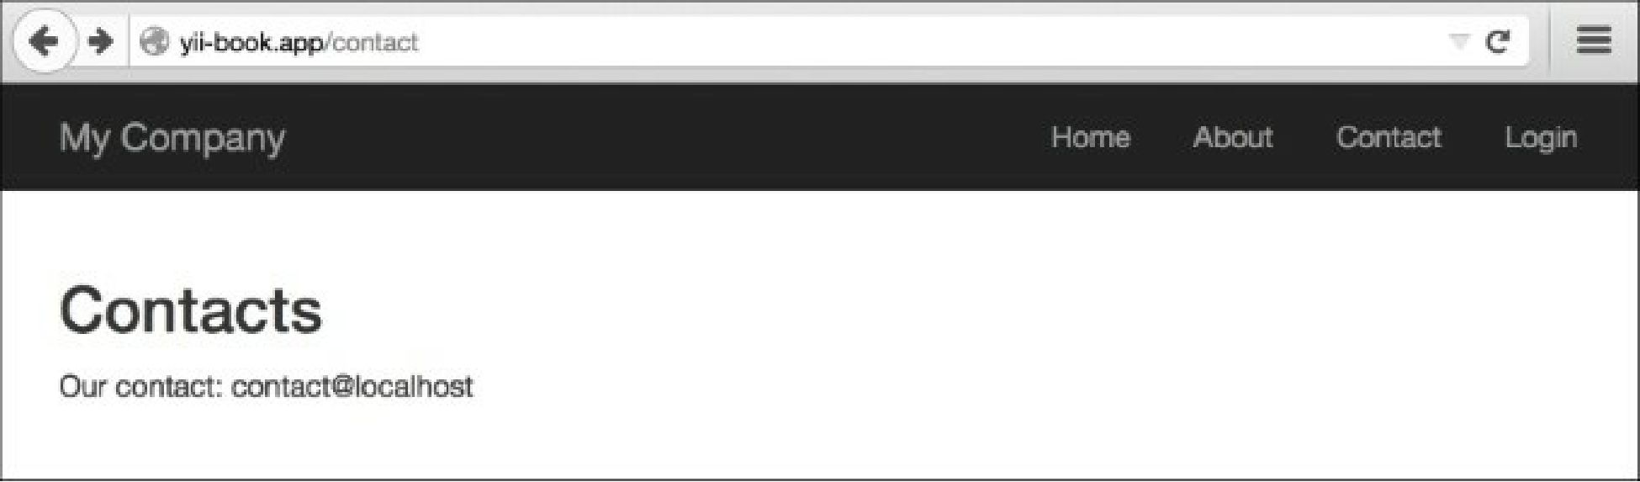

To configure the urlManager component, refer to the Configuring URL rules recipe.

See also

For further information, refer to the following URLs:

* [http://www.yiiframework.com/doc-2.0/yii-web-v'ewaction.html](http://www.yiiframework.com/doc-2.0/yii-web-viewaction.html)
* [http://www.yiiframework.com/doc-2.0/guide-structure-views.html#rendering-static-pages](http://www.yiiframework.com/doc-2.0/guide-structure-views.html%23rendering-static-pages)
* The Configuring URL rules recipe